

|  |
| --- |
| MTN.BI.07 Introduction to Data Warehousing  Introduction to Data Warehousing |
| Laboratory work |

Contents

1. Virtual machine setting 3

2. GIT 3

3. CHOOSE BUSINESS FOR YOUR PROJECT 3

# 1. Virtual machine setting

Import VM “BI 2018.ova”.

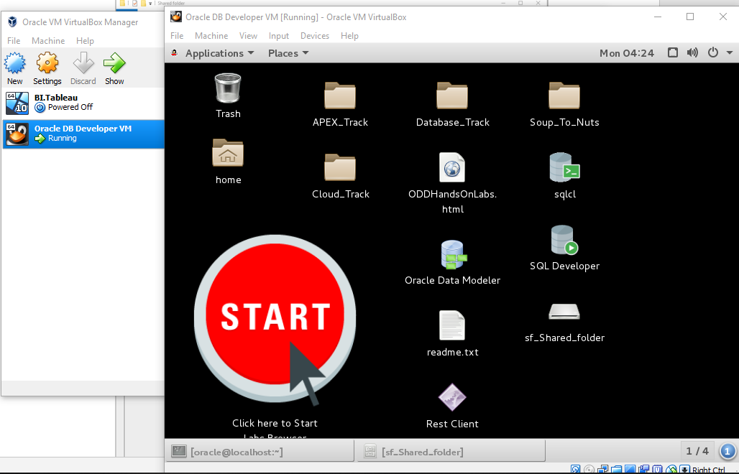

Set shared folder between your windows machine and remote machine (this folder might be your GIT folder)

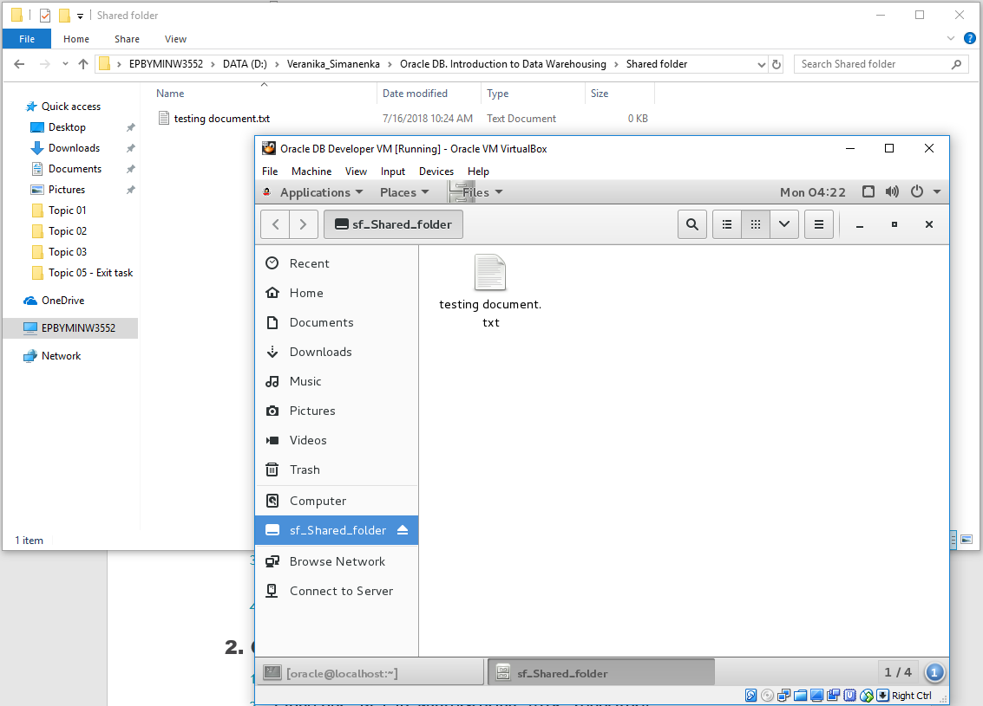

Connect to Oracle using sqldeveloper from your Windows machine (port forwarding in your virtual machine needs to be enabled)

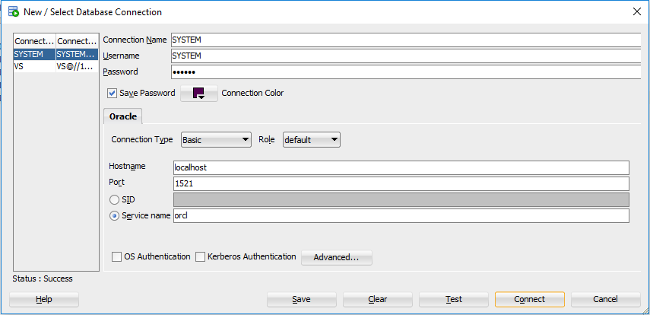

Create your user/schema (in Oracle) test_user – try new VM

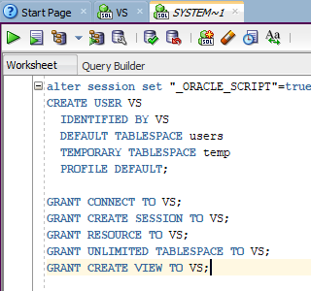

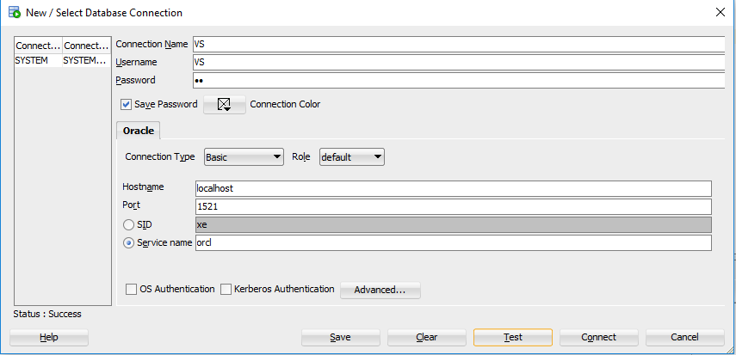

# 2. GIT

Pass GIT tutorial <https://githowto.com/>

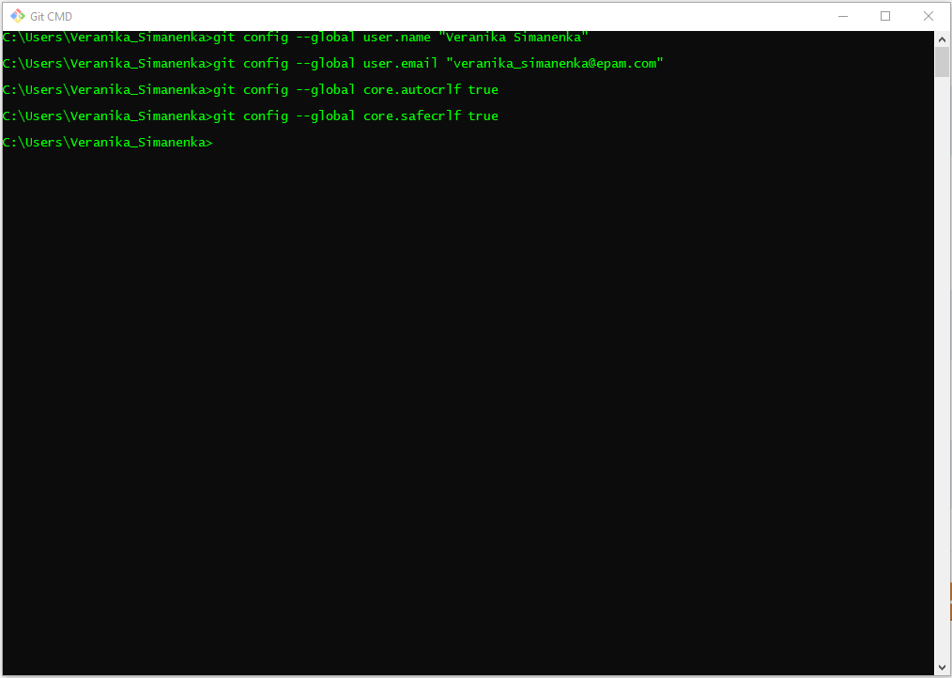

Clone our “BI_Lab_winter-spring_2018” repository

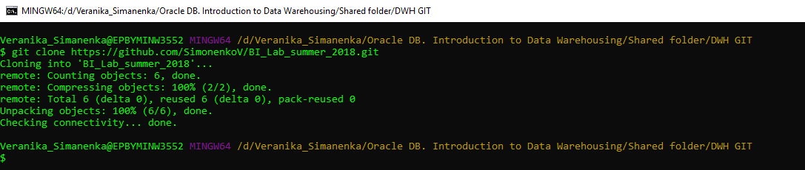

Cloned repository:

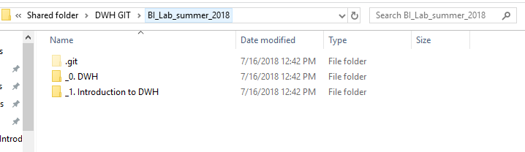

Add, commit and pull your personal folders to “BI_Lab_winter-spring_2018\_0. DWH\Project\” and “BI_Lab_winter-spring_2018\_1. Introduction to DWH\Tasks”, use “Name_Surname” template.

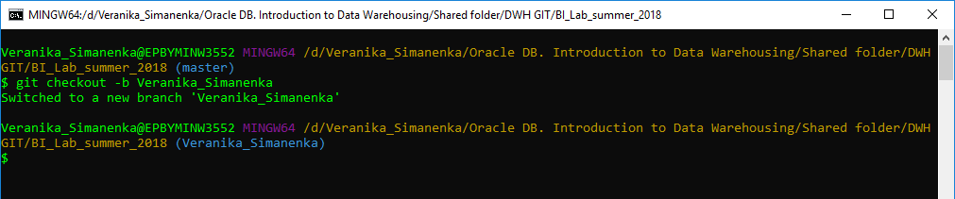

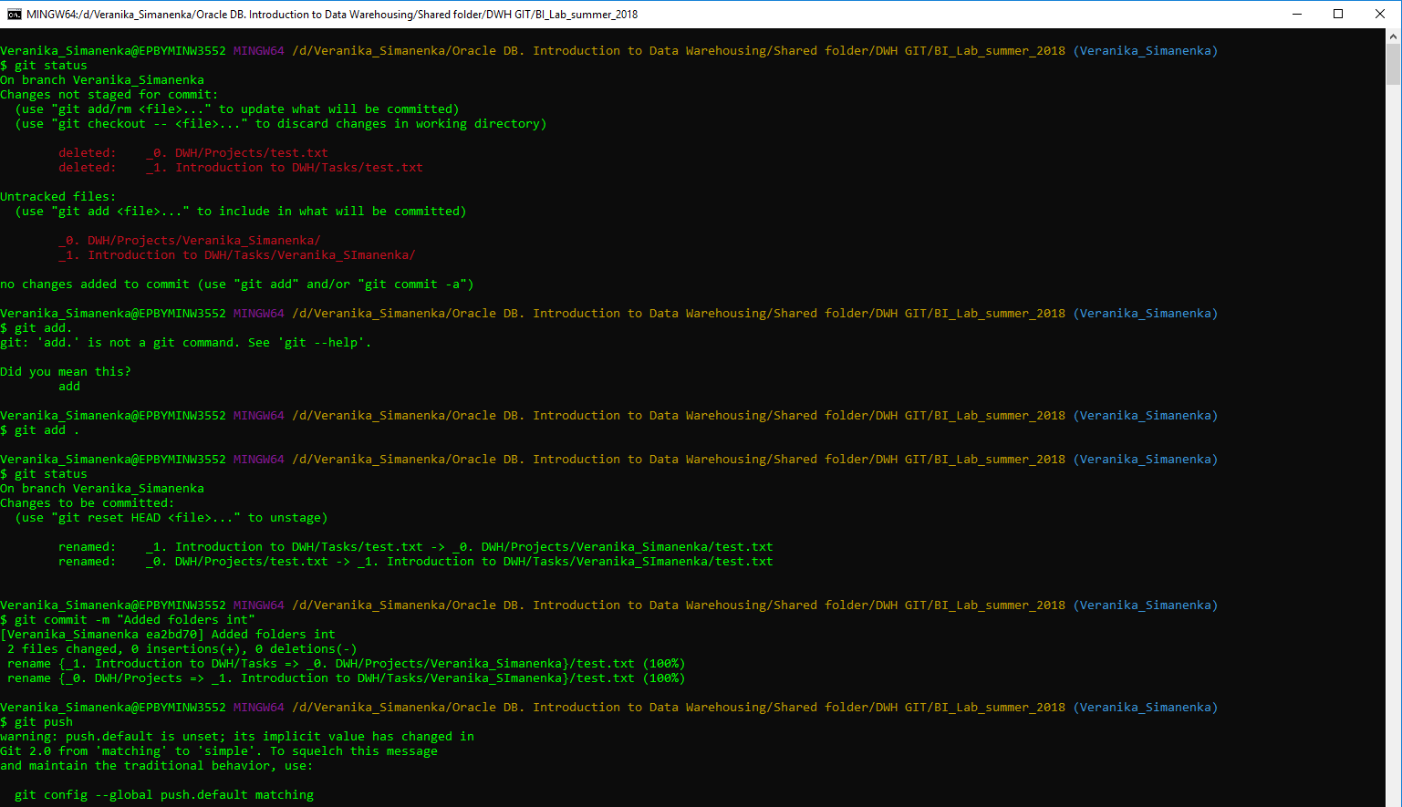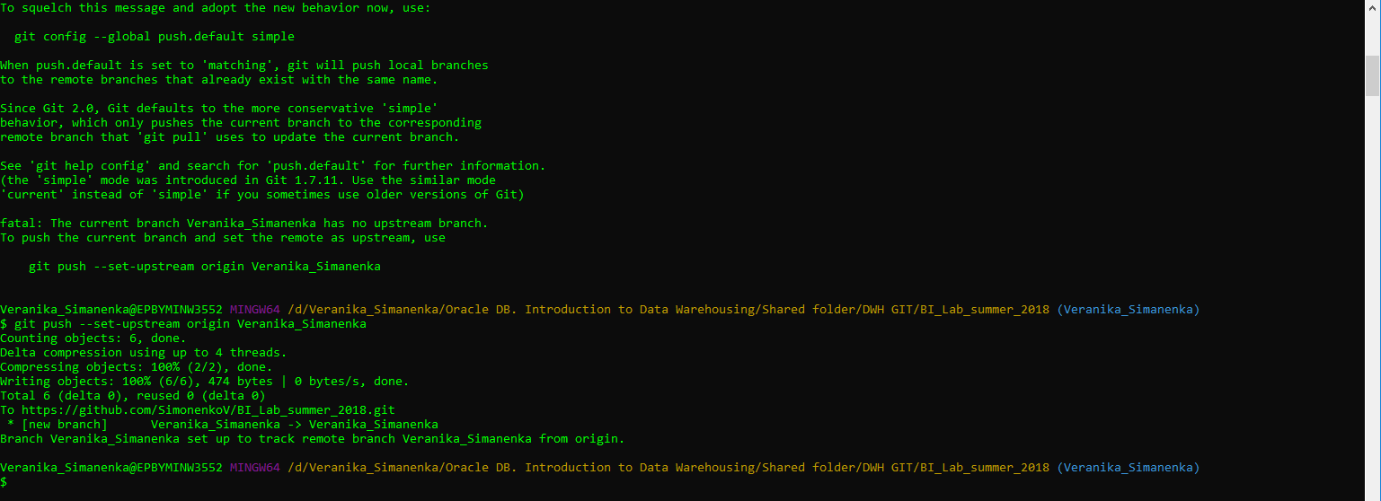

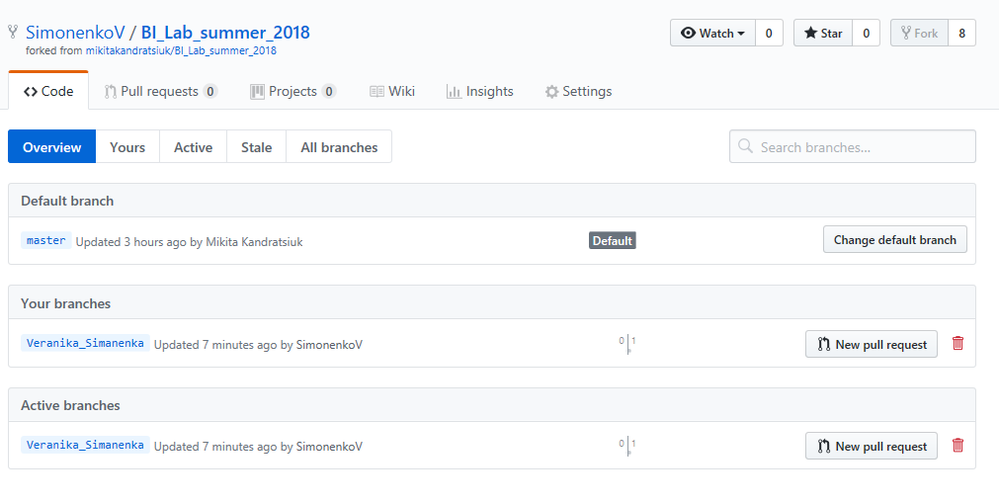

# 3. CHOOSE BUSINESS FOR YOUR PROJECT

* For the next lessons you’ll be creating document describing your chosen business and creating plan of implementing data warehousing for this business.
* During the ETL module you will implement DWH and ETL according to your plan.